Lab 2.1 Python Basic

Instructions

1. Answer the below question in the boxes if needed.
2. Code on your computer and zip all your code before submission.
3. Please submit the assignment after you finish.

Part 1 MCQ Assignment

**Q1 What will be the output of the following code?**

a = [1,2,3,4,5]

sum = 0

for ele in a:

  sum += ele

print(sum)

A. 15

B. 0

C. 20

D. None of these

Answer:

**Q2 What will be the output of the following code?**

a = 3

b = 1

print(a,b)

a,b = b,a

print(a,b)

1. 31 13
2. 31 31
3. 13 13
4. 13 31

Answer:

**Q3 What will the output be of ((500//7) % 5) ** 3?**

A. 1

B. 2.91

C. 71.42

D. 0

E. 8

Answer:

**Q4 What will be the output of the following expression?**

**print(36/4)**

1. 9.0
2. 9
3. 9.1
4. None of the above

Answer:

**Q5 What will be the output of the following expression?**

print(2*3**3*4)

A. 345

B. 216

C. 864

D. 768

Answer:

**Q6 What will be the output of the following code?**



1. 10
2. 0
3. Syntax error
4. None of these

Answer:

**Q7 What will be the output of the following code?**

samplelist = [10,20,30,40,50]

print(samplelist[-2])

* + - * 1. 40
        2. Index error
        3. 30
        4. None of these

Answer:

**Q8 What will be the output of the following code?**

aTup = (10, 20, 30, 40, 50, 60, 70, 80)

print(aTup[2:5])

1. (30,40,50)
2. (20,30,40,50)
3. None of the above

Answer:

**Q9 What will be the output of the following code?**

set1={10,20,30,40,50}

set2= {60,70,10,30,40,80,20,50}

print(set1.issubset(set2))

print(set2.issubset(set1))

1. False False
2. True False
3. None

Answer:

**Q10** **What will be the output of the following code?**

set1 = {10, 20, 30, 40}

set2 = {50, 20, "10", 60}

set3 = set1.union(set2)

print(set3)

1. {40,10,50,20,60,30}
2. {40,’ 10’, 50,20 60,30}
3. {40,10,’10’, 50,20,60,30}
4. Syntax error

Answer:

**Q11 What will be the output of the following code.**

dic1 = {"key1": 1, "key2": 2}

dic2 = {"key2": 2, "key1": 1}

print(dic1==dic2)

* + - * 1. True
        2. false
        3. error

Answer:

**Q12 What will be the output of the following code?**

for num in range(-2,-5,-1):

    print(num, end=", ")

* + - * 1. -2,-1,-3,-4
        2. -2,-1,0,1,2,3
        3. -2,-1,0
        4. -2,-3,-4

Answer:

**Q13 What will be the code of the following output?**

for num in range(10,14):

  for i in range(2,num):

    if num%i==1:

      print(num)

      break

* + - * 1. 10 11 12 13
        2. 11 13

Answer:

**Q14 What will be the output of the following code?**

def add(a, b):

    return a+5, b+5

result = add(3, 2)

print(result)

1. 15
2. 8
3. (8,7)
4. Error

Answer:

Part 2 Programming Task

Open the **lab2/Python_Basics_Exercise/Python_Graded_Questions_Netflix.ipynb** file and complete the code development for the corresponding question

The netflix dictionary contains a list of 100 titles along with their total number of views in the past. Based on the keys and values provided in this dictionary, answer the questions given below.

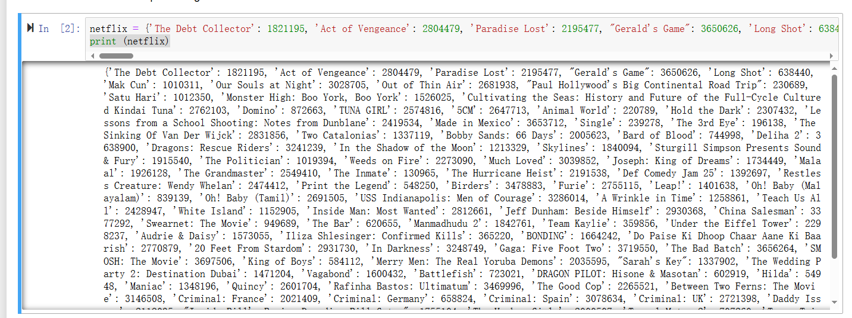

**Q1.** There's an Indian movie in the dictionary named Do Paise Ki Dhoop Chaar Aane Ki Baarish. What is the number of views for this movie?

**Q2.** Which of the shows is the most and least popular in terms of number of views?

**Q3.** Netflix has just received the number of views for the last week as well. Add these views to the total views and find the most popular title in terms of views. Also find out how many views this title has?

**Q4.** There's a movie in the dictionary named Vagabond. What is the number of views for this movie?

**Q5.** There are multiple movies having The Movie in it. What is the total number of views for these movies?